MINIMUM SPANNING TREE
KRUSKAL'S ALGORITHM
Q9 – Minimum Spanning Tree
Name: L. Ashraf Ali
Register No.: 192524192
Source Code, Output, Analysis and Documentation

1. Aim
To connect all nodes of a weighted network with minimum possible total cost using Kruskal’s Minimum Spanning Tree algorithm, while ensuring that no cycle is formed.

2. Problem Statement
A network engineer needs to connect multiple nodes in a network with minimum possible cost. Each connection has an associated weight. Using Kruskal’s algorithm, select a subset of edges that connects all nodes, does not contain cycles, and has minimum total weight.

3. Input
n = 4
Graph adjacency matrix:
0 2 3 0
2 0 15 2
3 15 0 13
0 2 13 0

4. Edge List
The non-zero undirected edges are:
- (0,1) = 2
- (0,2) = 3
- (1,2) = 15
- (1,3) = 2
- (2,3) = 13

5. Kruskal’s Algorithm
- Create a list of all edges and their weights.
- Sort all edges in ascending order of weight.
- Start with an empty MST.
- Consider each edge in sorted order.
- Add the edge if it does not create a cycle.
- Use Disjoint Set Union (Union-Find) to detect cycles efficiently.
- Stop after selecting n − 1 edges.

6. Edge Selection
Edge | Weight | Action | Reason
(0,1) | 2 | Select | No cycle
(1,3) | 2 | Select | No cycle
(0,2) | 3 | Select | No cycle
(2,3) | 13 | Reject | Would create a cycle
(1,2) | 15 | Reject | Would create a cycle

7. Minimum Spanning Tree
Selected MST edges:
- (0,1) with weight 2
- (1,3) with weight 2
- (0,2) with weight 3
MST Cost = 2 + 2 + 3 = 7

8. Why Cycles Are Avoided
An MST for n vertices must contain exactly n − 1 edges. If an edge connects two vertices that are already connected through the selected edges, adding it would create a cycle and would not improve connectivity. Kruskal therefore rejects such an edge.

9. Python Source Code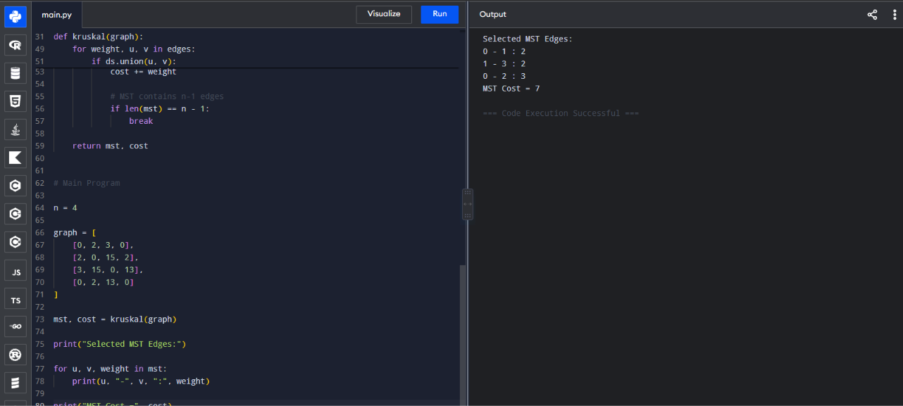

10. Correctness Analysis
Kruskal’s algorithm processes edges from smallest to largest weight and adds an edge only when it connects two different components. The cycle test guarantees that every selected edge is safe. Once n − 1 edges have been selected, all vertices are connected and the resulting spanning tree has minimum total weight. For the given graph, the selected edges have weights 2, 2 and 3, giving total cost 7.

11. Complexity Analysis
Let V be the number of vertices and E the number of edges. Sorting the edges takes O(E log E) time. Union-Find operations take approximately O(E α(V)), where α is the inverse Ackermann function. Therefore, the overall complexity is O(E log E). The space complexity is O(V + E).

12. Result Analysis
The MST connects all four nodes using three edges, which is exactly n − 1 edges. The minimum total network connection cost is 7. The expensive edges with weights 13 and 15 are unnecessary because all nodes are already connected by cheaper edges.

13. Conclusion
Kruskal’s algorithm successfully finds the Minimum Spanning Tree by sorting edges according to weight and using cycle detection. For the given graph, the MST consists of edges (0,1), (1,3), and (0,2), with total cost 7. This demonstrates how a greedy algorithm can efficiently minimize network connection cost while maintaining connectivity.

14. Student Details
Name: L. Ashraf Ali
Register No.: 192524192

